**PRACTICAL: 02**

**AIM: - To perform IP exercises, Sharing and MAP network drive.**

**Concept of overview**

In this practical we will learn , how to allocate an IP address to the host machine through which it can be communicate then learn about sharing of files with control access and at last how to map drive to the client machine as like client can access as a local drive.

**Introduction:**

**IPv4 Address Classes (32 bits)**

The IPv4 address space can be subdivided into 5 **classes** - Class A, B, C, D and E

|  |  |  |
| --- | --- | --- |
| Class : A |  | Address from 0.0.0.0 to 127.255.255.255 |
|  | – | 127 is reserved for loop back functions |
|  | – | Class A reserved for governments |
| Class: B |  | Address from 128.0.0.0 to 191.255.255.255 |
|  | – | The last IP Address is the Broadcast Address |
|  | – | 65543 Hosts per Network |
|  | – | Class B reserved for medium companies |
| Class: C |  | Address from 192.0.0.0 to 223.255.255.255 |
|  | – | The last IP Address is the Broadcast Address |
|  | – | 254 Hosts per Network |
|  | – | Class C reserved for small companies |
| Class: D | | Address from 224.0.0.0 to 239.255.255.255  Class D are reserved for multicasting |
| Class: E | | Address from 240.0.0.0 to 255.255.255.255 |

Class E are reserved for future use OR experimental use

**Default Subnet Mask**

* **CLASS A - 255.0.0.0**
* **CLASS B - 255.255.0.0**
* **CLASS C - 255.255.255.0**

**IP exercises:**

How to provide an IP address to the host machine? We will have IPv4 and IPv6. Hence we will use IPv4 (for e.g. 192.168.0.1 from class C). For assigning an IP address, first we have to go properties of my network neighborhood then again further move to properties of Local are connection. Over there you can find protocol properties and can assign dotted decimal 32-bit IP address, subnet mask, gateway, DNS as per our requirement to access network resources.

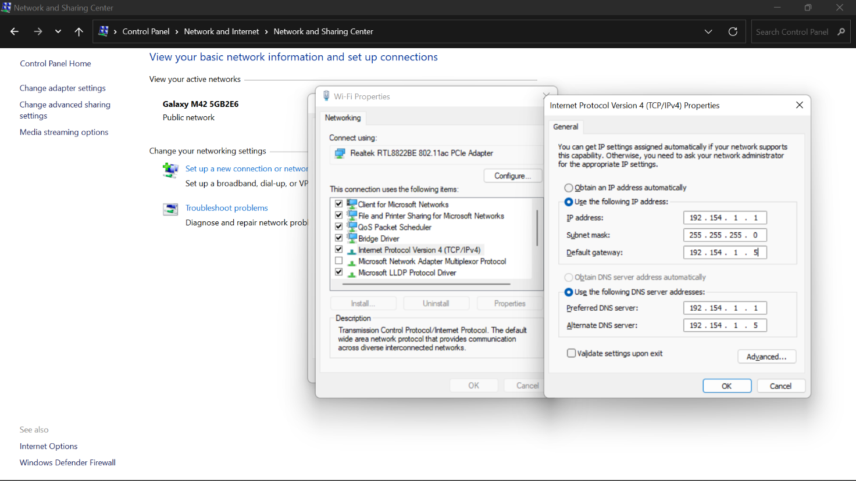

Using Static IPs prevents address conflicts between devices and allows you to manage them more easily.

# Configure your PC to use its own IP address, (step by step in win 7)

1. Open the Network and Sharing Center window.

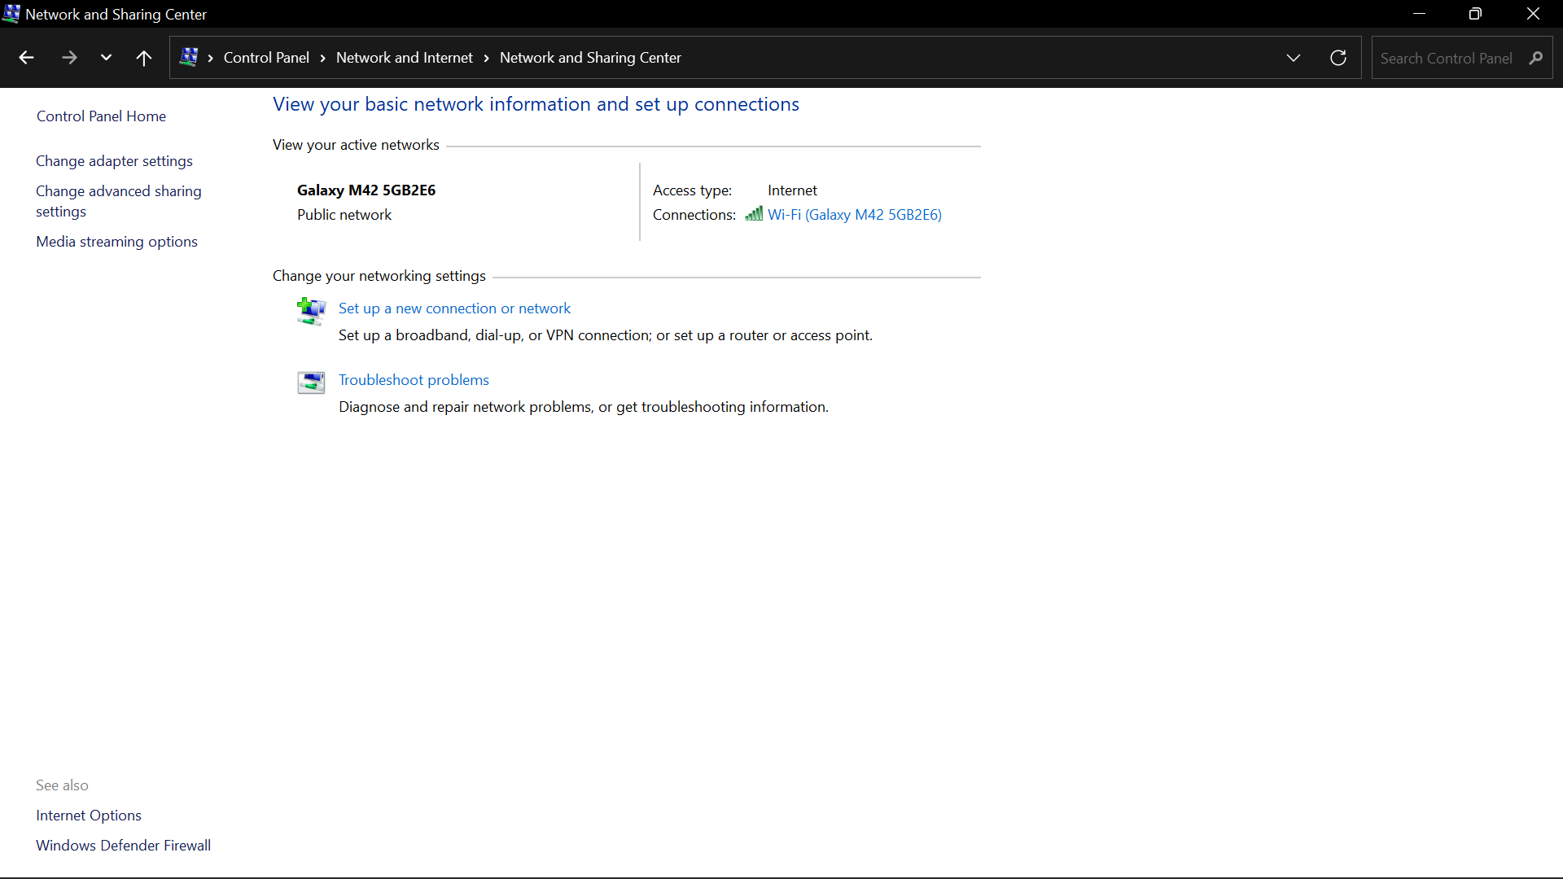

1. On the right side of the window, choose the link Local Area Connection. (e.g. Ethernet 2)
2. In the Status dialog box, click the Properties button.
3. A Properties dialog box for the connection appears. It lists the various protocols and services being used by the connection.

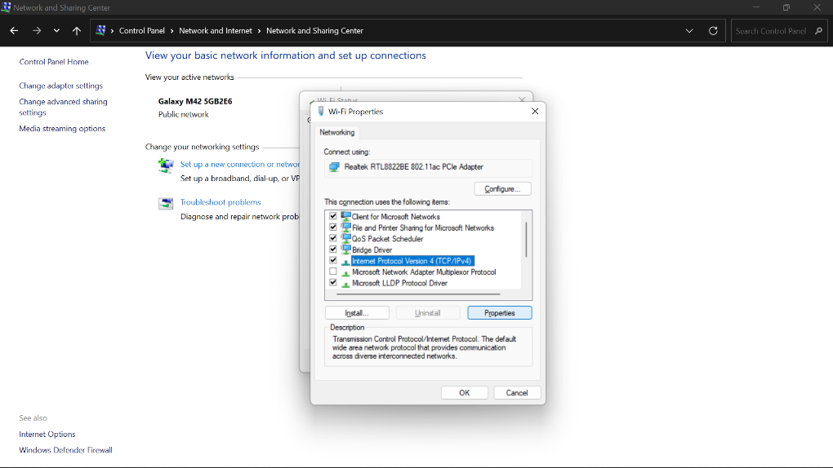

1. Select the service titled Internet Protocol Version 4 (TCP/IPv4).
2. Click the Properties button.
3. The dialog box labeled Internet Protocol Version 4 (TCP/IPv4) Properties appears.
4. Choose the option Use the Following IP Address.

1. Type the IP address.

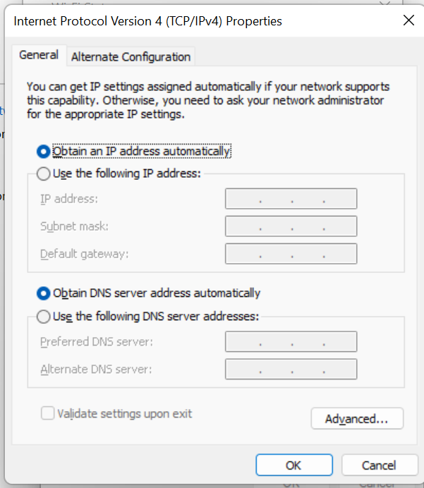

1. At this point, you must know what you’re doing. Seriously. Typing an improper IP address, or one that’s out of range, means that your computer cannot use the network.
2. Type a subnet mask.
3. For a local-area network, the value is usually 255.255.255.0, but it could be something else depending on the specifics of your network.
4. Type the default gateway address.
5. The default gateway address is the IP address for the network’s router. Because DHCP also obtains the address for the DNS server, which helps your computer find addresses on the Internet
6. Type the address of the preferred DNS server.
7. This value is obtained from your ISP.
8. Type the address for the alternative DNS server.

The alternate DNS server’s IP address is also something that your ISP must provide.

1. Click OK to close the Internet Protocol Version 4 (TCP/IPv4) Properties dialog box.
2. Close the other open dialog boxes and windows.

Now you can open the command prompt and do an *ipconfig* to see the network adapter settings have been successfully changed.

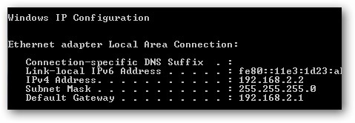

**Sharing:**

Network is use for sharing a resources and files, also for transferring files between nodes in the networks. We can also set permission for access shared file among the networks.

**File and Printer Sharing for Microsoft Networks:**

The File and Printer Sharing for Microsoft Networks component allows computers on a network to access resources on other computers using a Microsoft network. This component is installed and enabled by default. It is enabled per connection using TCP/IP and is necessary to share local folders. **(Share in Winwow7)**

Your network card’s properties window will appear, then tick File and Printer Sharing for Microsoft Networks if it's not tick, finally click OK.

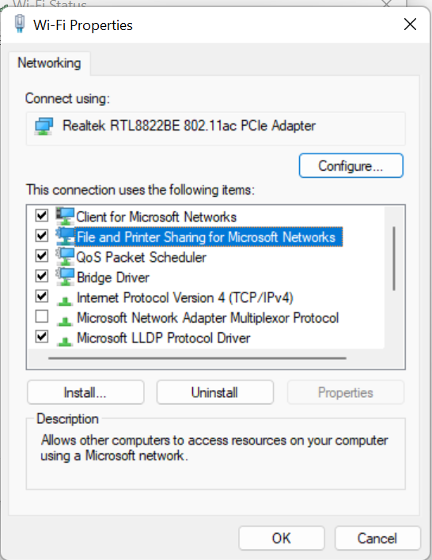

Let’s move back to Network and Sharing Center window, make sure you have selected the appropriate network location type before enabling file sharing, mostly home network or work network type. In this case, my network location type is home network.

**Note:** I would also advise you to set the same Workgroup for all computers on the same network in order to ease the file sharing.

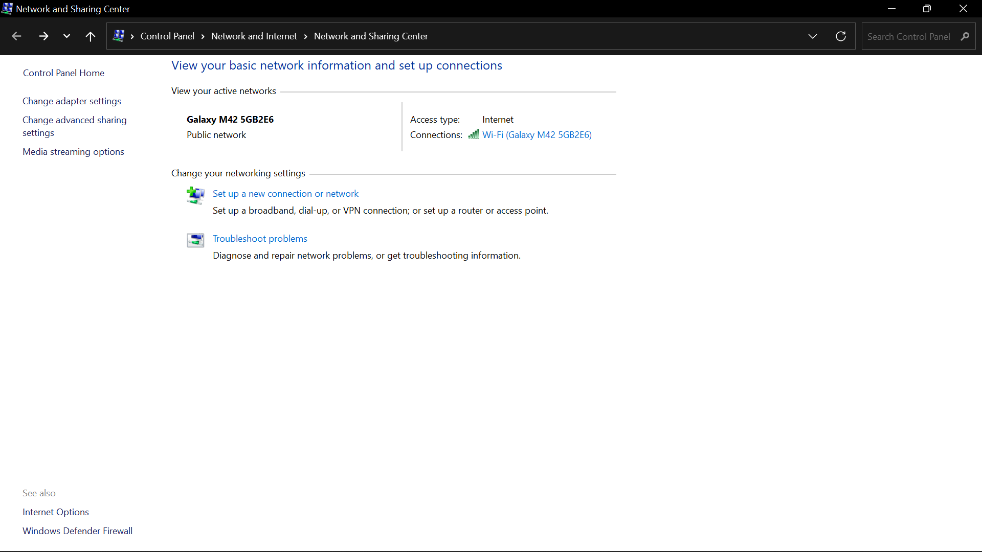

Now you can proceed to click on Change advanced sharing settings.

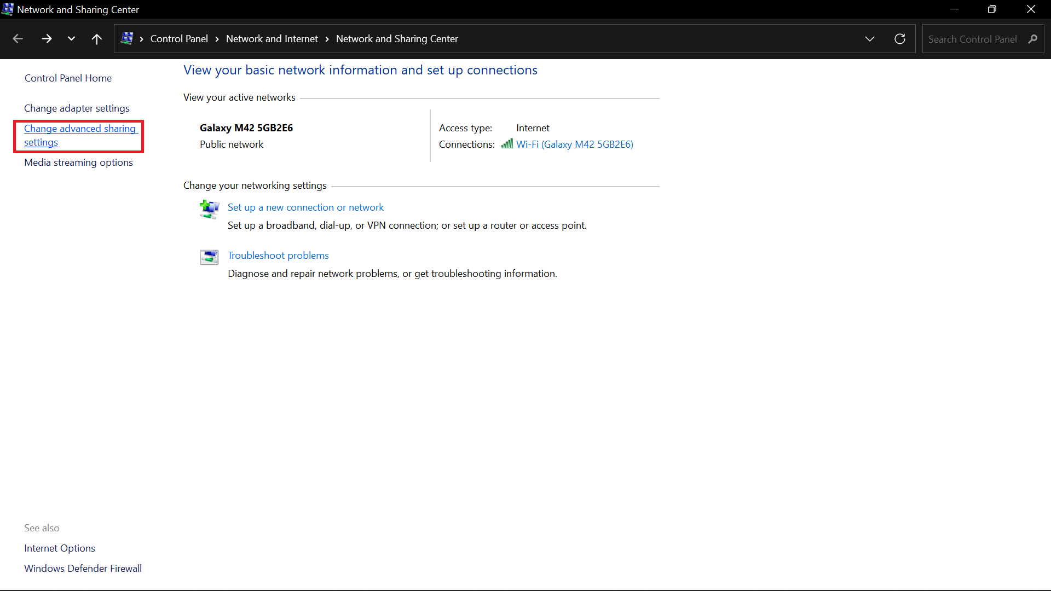

Here you need to locate your current set profile (home or network in this case), and turn on/off following settings. Click on Save changes at last.

Turn on file and printer sharing

Turn off password protected sharing

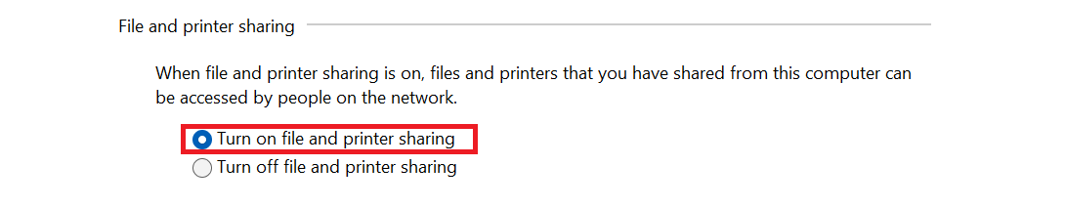

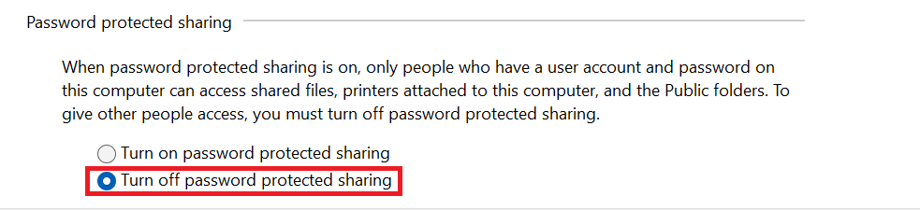

Ok! Let’s start to enable file sharing in Windows 7, right click the file or folder you plan to share,

File Sharing window will appear, and here you can select or key in the people you would like to share the file/folder

**Note:** You can set 2 different permission levels for each people you selected:

**Read** - Can open, but not modify or delete the file.

**Read/Write** - Can open, modify, or delete the file.

**To share folders with other users on your network** (Window XP)

1. Open **My Documents** in Windows Explorer. Click **Start**, point to **All Programs**, point to **Accessories**, and then click **Windows Explorer**.
2. Click the folder you want to share.
3. Click **Share this folder** in **File and Folder Tasks**.
4. In the **Properties** dialog box select the radio button **Share this folder** to share the folder with other users on your network, as shown in Figure 1 below.

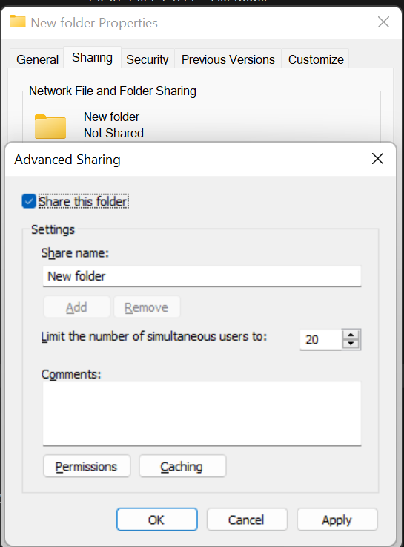

**Figure 1. Sharing a folder on a network**

1. To change the name of the folder on the network, type a new name for the folder in the **Share name** text box. This will not change the name of the folder on your computer.

**Note** The Sharing option is not available for the Documents and Settings, Program Files, and Windows system folders. In addition, you cannot share folders in other users’ profiles.

**To set, view, change, or remove file and folder permissions**

1. Open Windows Explorer, and then locate the file or folder for which you want to set permissions. To open Windows Explore click **Start**, point to **All Programs**, point to **Accessories**, and then click **Windows Explorer**.
2. Right-click the file or folder, click **Properties**, and then click the **Security** tab as shown in Figure 2 below.

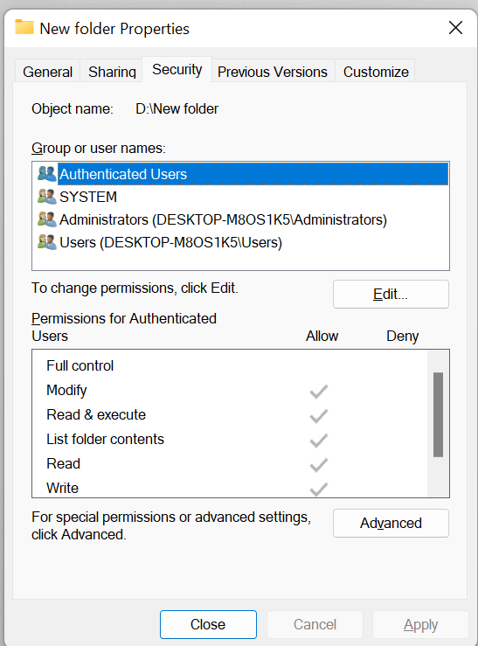

**Figure 2. Setting file and folder permissions**

Shared can be accessed by authorized network user and perform read, write, or access according to given permissions at the time of sharing. Client server architecture can be generated, where shared machine can act as a server & remotely access machine as a client which can use resources as per client request and based on access control.

1. To set permissions for a group or user that does not appear in the Group or user names box, click Add. Type the name of the group or user you want to set permissions for and then click OK, as shown in Figure 3 below.

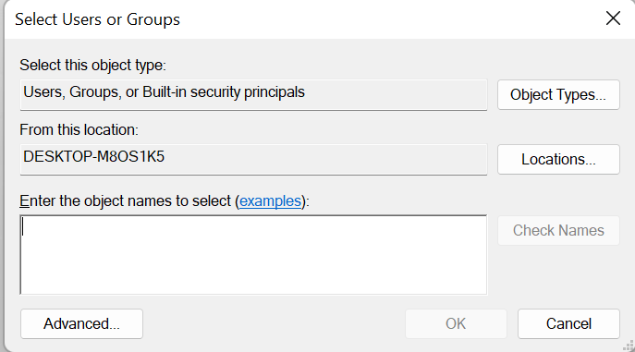

**Figure 3. Adding new group or user permissions**

1. To change or remove permissions from an existing group or user, click the name of the group or user and do one of the following, as shown in Figure 2 above:

o To allow or deny permission, in the **Permissions for**...box; select the **Allow** or **Deny** check box. o To remove the group or user from the **Group or user names** box, click **Remove**.

**# Students have to perform this practically with local LAN in the laboratory Notes**

* In Windows XP Professional, the **Everyone** group no longer includes Anonymous Logon.
* You can set file and folder permissions only on drives formatted to use NTFS.
* To change permissions you must be the owner, or have been granted permission to do so by the owner.
* Groups or users granted **Full Control** for a folder can delete files and subfolders within that folder regardless of the permissions protecting the files and subfolders.
* If the check boxes under **Permissions** for user or group are shaded or if the **Remove** button is unavailable, then the file or folder has inherited permissions from the parent folder.
* When adding a new user or group, by default, this user or group will have **Read & Execute, List Folder Contents**, and **Read** permissions.

**MAP network drive:**

In the client server architecture or in the local LAN, client machine can access mapped drive as a local hard drive through networking.

How to map network drive in windows. (e.g. windows XP in our laboratory)

1. Find the **“My Computer”** icon either on the desktop, or by clicking **“Start”**.
2. **Right Click “My Computer”** and choose **“Map Network Drive”**.

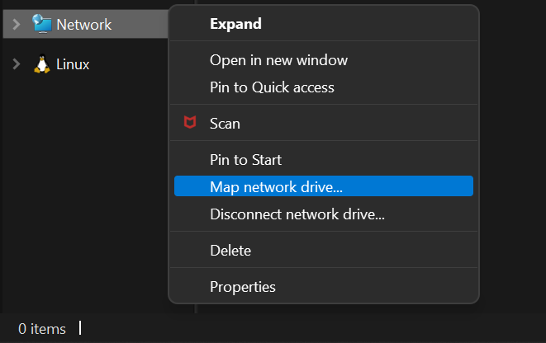

1. Choose a drive letter from the drop down menu (such as N:) and type in the folder you wish to map (such as \\jupiter\acc). Also check **“Reconnect at Login”**if you want this drive available every time you restart your computer.

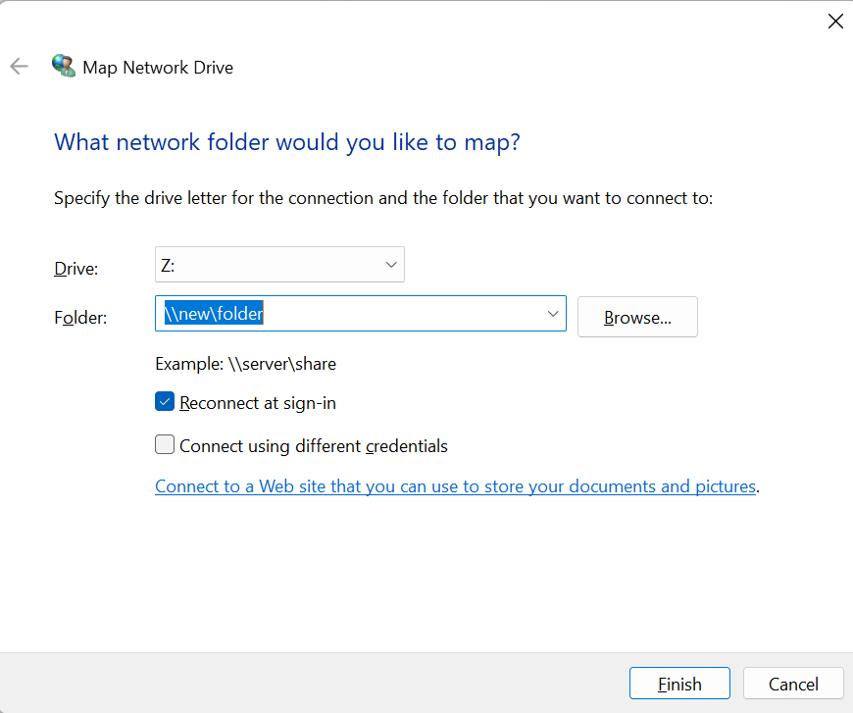

**Lab Exercise**

1. **What are the Advantages of Network**

**___________________________________________________________________________**

**___________________________________________________________________________ ___________________________________________________________________________**

**___________________________________________________________________________**

**___________________________________________________________________________**

**__________________________________________________________________________**

1. **Write a short note of Ethernet LAN(network)**

**___________________________________________________________________________**

**___________________________________________________________________________ ___________________________________________________________________________ ___________________________________________________________________________ ___________________________________________________________________________ ___________________________________________________________________________**

**___________________________________________________________________________**

1. **Compare IPv4 & IPv6 with example**

|  |  |
| --- | --- |
|  |  |
|  |  |

1. **Compare Peer to Peer & Client- Server Architecture**

|  |  |  |
| --- | --- | --- |
|  |  |  |
|  |  |  |

***Sign of Faculty.***